SURAJ KUMAR
1NT19IS167
Program 1:

Use The mongo dB surajbase to Exercise NOSQL Queries to Demonstrate the following with an USECASE

1.CREATE surajBASE:

use surajBASE_NAME is used to create surajbase.
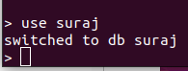
> use suraj

2.Basic CRUD operations

insert one
db.suraj.insertOne(
... { "name":"madhu",
... "city":"bangalore"})
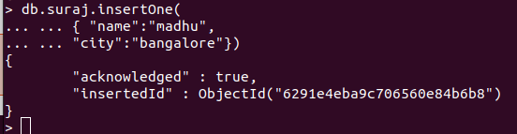

insert many
>inserting many
db.suraj.insertMany([
... {"name":"vinayak","age":22,"elective":"EDA"},
... {"name":"sanjeev","age":21,"elective":"CC"},
... {"name":"madhu","age":21,"elective":"cloud"}])
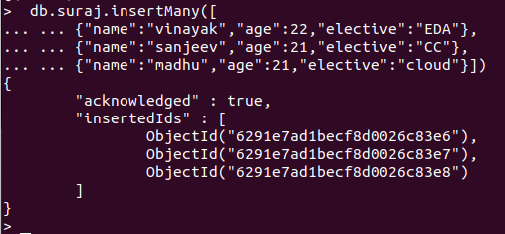

READING
db.suraj.find()

{ "_id" : ObjectId("628f3adda44adf31b7d490dd"), "name" : "madhu", "city" : "bangalore" }
{ "_id" : ObjectId("628f3bdaa44adf31b7d490e1"), "name" : "vinayak", "age" : 22, "elective" : "EDA" }
{ "_id" : ObjectId("628f3bdaa44adf31b7d490e2"), "name" : "sanjeev", "age" : 21, "elective" : "CC" }
{ "_id" : ObjectId("628f3bdaa44adf31b7d490e3"), "name" : "madhu", "age" : 21, "elective" : "cloud" }

> db.suraj.find()
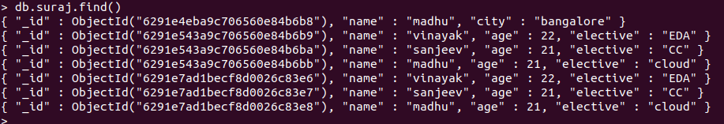
> db.suraj.find().pretty()

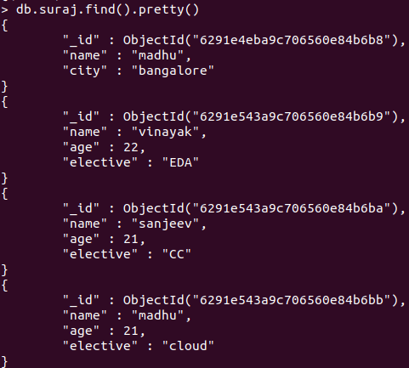

updatemany

db.suraj.updateMany(
... {},
... {
... $set:{"college":"nmit"}
... }
... )
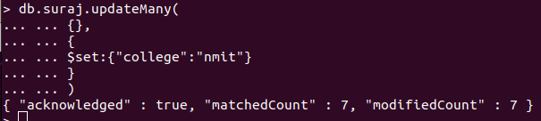
> db.suraj.find().pretty()

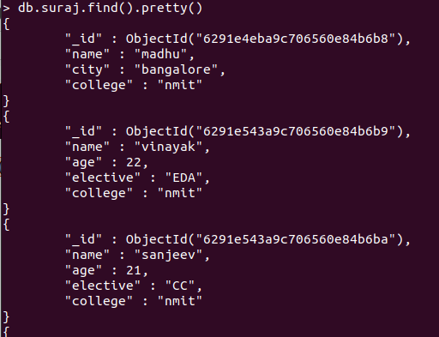

updateOne():
db.suraj.updateOne(
... {"name":"madhu"},
... {
... $set:{"city":"tiptur"}
... }
... )

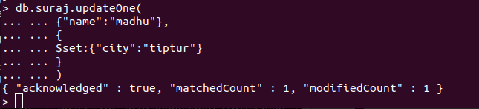
madhu city chnages to bangalore to tiptur

deleteOne()

> db.suraj.deleteOne({"elective":"cloud"})

madhu got deleted where elective was cloud
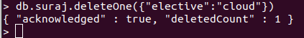

db.lab.insertMany([
... {"name":"vinayak","age":22,"elective":"EDA"},
... {"name":"sanjeev","age":21,"elective":"CC"},
... {"name":"madhu","age":21,"elective":"cloud"}])

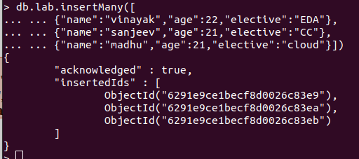

deleteMany():
>db.suraj.deleteMany({“college”:”nmit”})
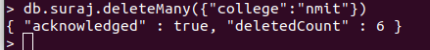

\\ suraj where college = nmit got deleted and i had to re insert suraj...\\

insertmany()

> db.suraj.insertMany([ {"name":"vinayak","age":22,"college":"nmit"},{"name":"sanjeev","age":21,"college":"nmit"}, {"name":"sohan","city":"bangalore","college":"nmit"},{"name":"pratheek","city":"mangalore","college":"nmit"}, {"name":"madhu","city":"tiptur","college":"nmit"}])
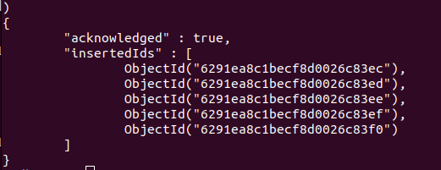

Replacing the document:

replaceOne():

db.suraj.replaceOne(
{"name" : "vinayak"}, {"name" : "praneeth", "age" : "22", "college" : "nmit"})
{ "acknowledged" : true, "matchedCount" : 1, "modifiedCount" : 1 }

vinayak changed to praneeth

AGGREATE FUNCTIONS

db.suraj.insertMany([
... {"name":"vinayak","age":22,"elective":"EDA"},
... {"name":"sanjeev","age":21,"elective":"CC"},
... {"name":"madhu","age":21,"elective":"cloud"}])

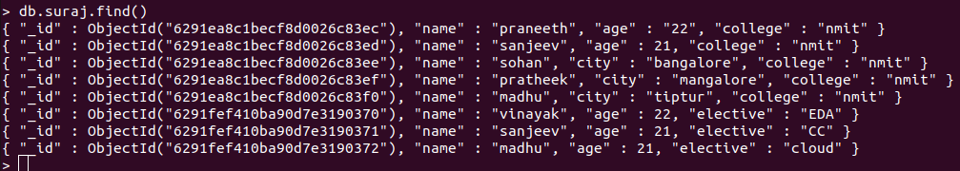

Creating Aggerate pipeline
Count:
Count the number of students with age :21
> db.suraj.aggregate([{$match:{age:21}},{$count:"Number of students with age :21"}])
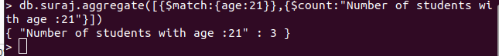
Sum
Sum of ages of female
> db.suraj.aggregate([{$match:{gender: "F"}},{$group:{_id : null,sum :{$sum:"$age"}}}])
Sum of ages of male
> db.suraj.aggregate([{$match:{gender: "M"}},{$group:{_id : null,sum: {$sum: "$age" }}}])
Sum of all the ages
> db.suraj.aggregate([{$match:{}},{$group:{_id : null,sum:{$sum:"$age"}}}])

Average
Average of all the ages
> db.suraj.aggregate([{$match:{}},{$group:{_id : null,avg:{$avg:"$age"}}}])

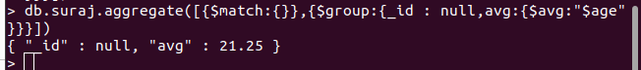

Max &Min
Find the maximum age among all
> db.suraj.aggregate([{$group:{_id : "age",aggregate_age:{$min:"$age"}}}])
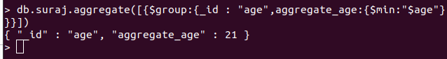
Find the minimum age among all
> db.suraj.aggregate([{$group:{_id : "age",aggregate_age:{$max:"$age"}}}])
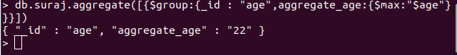

First & Last values
Find the first name in surajbase
> db.suraj.aggregate([{$group:{_id: "Name" ,aggregate_Name:{$first:"$Name"}}}])

Find the last name in surajbase
> db.suraj.aggregate([{$group:{_id: "Name" ,aggregate_Name:{$last:"$Name"}}}])

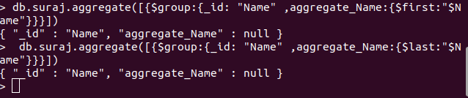

Insert suraj
>db.suraj.insertMany([{"Name":"Rani","age":22,"gender":"F"},{"Name":"Mohan","age":20,"gender":"F"}, {"Name":"Sita","age":21,"gender":"F"}])
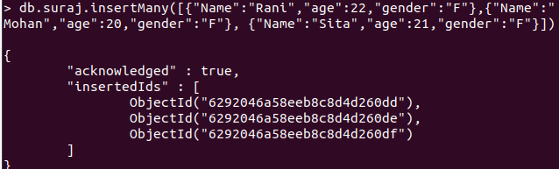
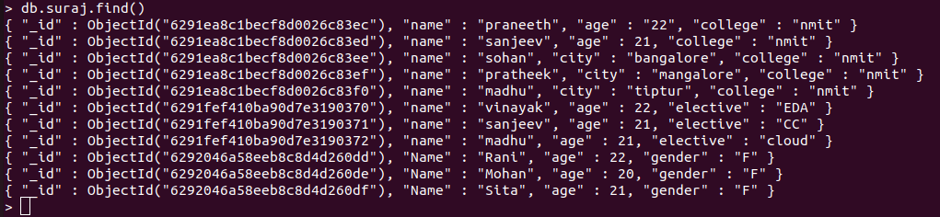

MAP REDUCE FUNCTIONS

AVERAGE:
>var map=function(){emit(this.name,this.age)};
>var reduce=function(name,age){return Array.avg(age);};
>db.suraj.mapReduce(map,reduce,{out:”newcollection”});

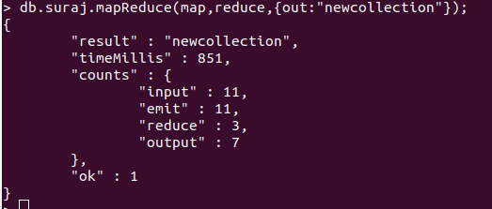

>db.newcollection.find()

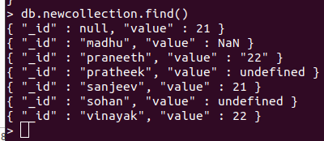

SUM:

>var map=function(){emit(this.name,this.age)};
>var reduce=function(name,age){return Array.avg(age);};
>db.suraj.mapReduce(map,reduce,{out:”newcollection”});
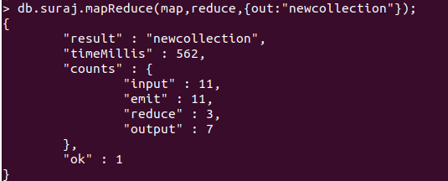

>db.newcollection.find()
